FFGLVolume plugin

1. First, we need a contrast image. Apply the plugin to the composition (clip, layer). Nothing really changed except fps.

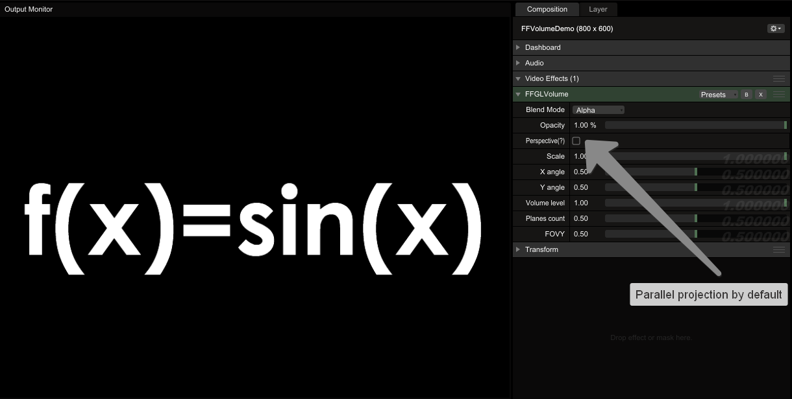

1. Change projection mode. Areas with nonzero luminance extrudes along depth axis:

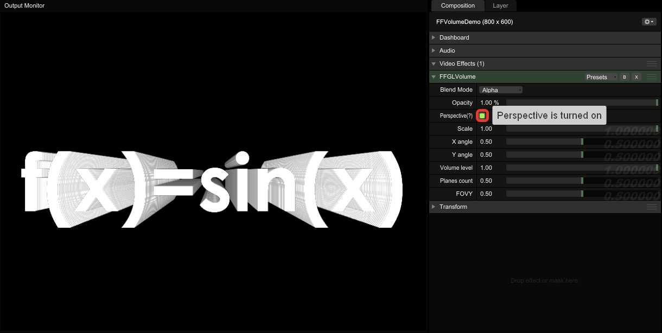

1. You can turn this pseudo-volume along X and Y axis:

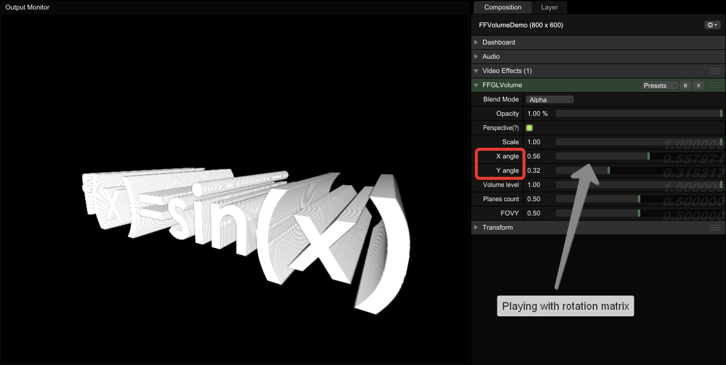

1. Next step – setting the volume planes count:

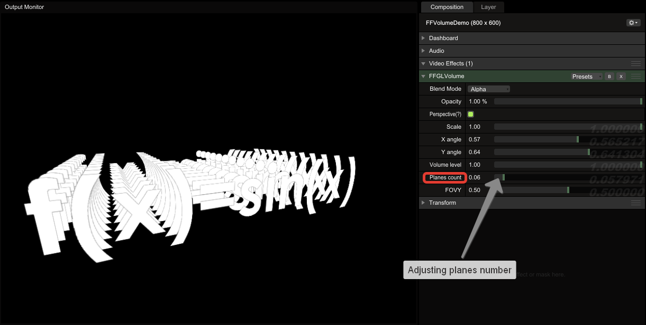

1. Setting volume depth and FOVY (field of view along y-axis):

